**Management Insights in Consumer Goods Domain**

**Company**: Atliq Hardwares -One of the leading computer hardware producers in India.

**Tables:** 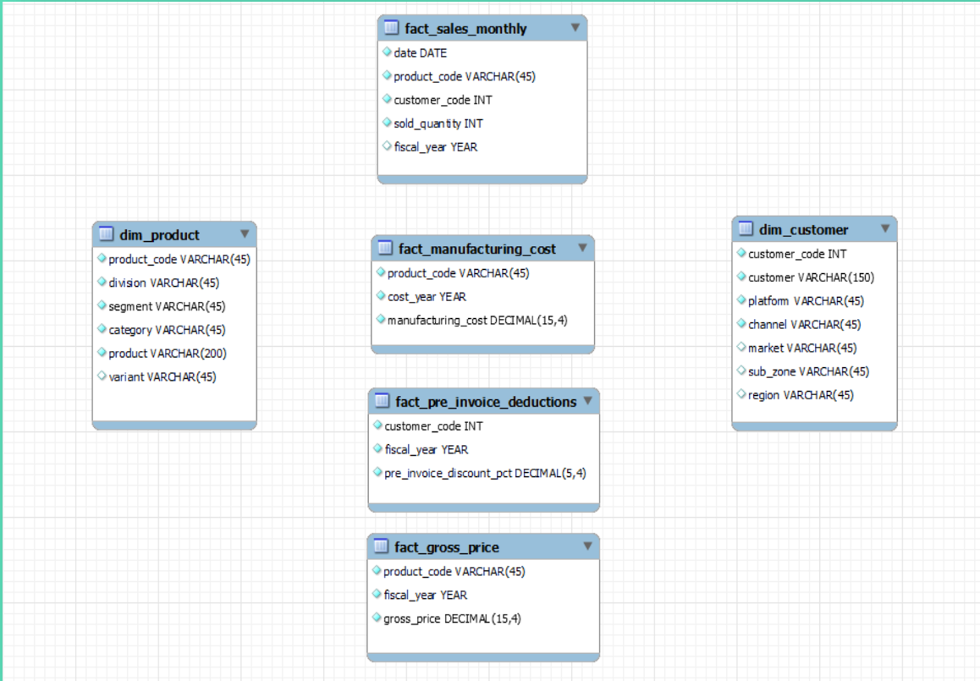

* **REQ1:** Provide the list of markets in which customer "Atliq Exclusive" operates its business in the APAC region.

This shows that we have majorly 8 markets in APAC region. This helps in finding the neighboring market to Indian Market so that export and import can be improved.

* **REQ2:** What is the percentage of unique product increase in 2021 vs. 2020?

There is 36% increase in count of unique products in 2021. This means that Atliq Exclusive is innovating continuously and launching new products day by day with advancement in technologies.

* **REQ3:** Provide a report with all the unique product counts for each segment and sort them in descending order of product counts.

In this query, we got the info about various segments in which the company manufactures and also the number of unique products in each segment. Here, we can see that the company manufactures many varieties of notebooks and accessories while there are less products in desktop, storage and networking segments. So, more products can be launched in these segments depending upon their sales and manufacturing costs. Also, packaged deals can be offered to customers combining highest and lowest sold segments. Gift cards, student discounts, cashbacks, membership, free vouchers can be introduced.

* **REQ4:** Get the products that have the highest and lowest manufacturing costs.

Here, from multilayer card, we can see that a desktop model has highest manufacturing cost while a mouse model has lowest manufacturing cost. Here, we can consider reducing the production of that desktop model, depending its sale. In case of mouse, considering the demand, the company might increase production and selling price too.

* **REQ5:** Generate a report which contains the top 5 customers who received an average high pre_invoice discount_pct for the fiscal year 2021 and in the Indian market.

Here, we can see that the company offered nearly equal avg discount to each of its top 5 customers in Indian market, which is nearly 30%. Company can provide similar discount rates to other customers as well which might increase customer sales too. This can ensure more orders to Atliq Exclusive form their end. Also, customer company relations can be improved.

* **REQ6:** Get the complete report of the Gross sales amount for the customer “Atliq Exclusive” for each month. This analysis helps to get an idea of low and high performing months and take strategic decisions.

Through the line chart, we can see that nov is the month of getting better sales every year. Company can increase production this month every year. Also, selling price can be increased in this month to book high profits. Apart from this, we can see that covid 19 has affected the sales as sales are getting decreased from Jan 2020 till August 2020, while from Sep 2020, as Work from home came into picture, there is sudden increase in the sales till Nov 2020. Again, there is a dip in line chart from Dec 2020 and continuous crest and trough are visible every month. This crest and trough can be avoided by providing better discounts, giving various offers on bulk purchasing. Also, improving product Quality can be beneficial. R&D activities should be increased to launch more products in affected segment. Sudden increase in sales in Sep 2020 shows that Company has recovered fast from pandemic.

* **REQ7:** In which quarter of 2020, got the maximum total_sold_quantity?

Here, fiscal year 2020 of atliq exclusive starts from Sep 2019. So, from graph, we can see that Q1 has maximum sold quantity which decreased in Q2 and further decreased in Q3 due to pandemic. In Q4, more quantities are sold in comparison to Q3. This again shows that the company recovered soon from pandemic. This shows that Q1 was most beneficial quarter in FY2020.